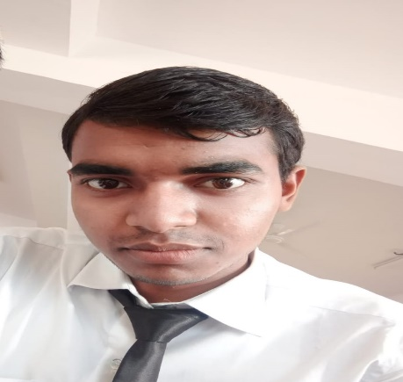

**ABOUT**

Bachelor of Technology

student.

A second-year Computer

Science Engineering

undergraduate student

at Lovely Professional

University with an

interest in emerging

technologies. Passionate

about programming and

working towards

developing new skills.

**CONTACT ME**

6267114430

vishwajeetsinghchouhan46

@gmail.com

Sanawad,451111,Distr

ict-Khargone (M.P)

**PROJECTS**

**EDUCATION**

LOVELY PROFESSIONAL UNIVERSITY

*Bachelor of Technology(Computer*

*Science), in progress.*

LOVELY PROFESSIONAL UNIVERSITY

2022-2025

**LANGUAGE**

Native English.

**COMPUTER SKILLS**

C++

Python

**DIPANSHU**

**RAJ**

*Student*

Spreadsheet.

Slide presentation.

https://www.linkedin.com/in/dipanshu-r-5009bb22a

**Courier Management System**

Developed using Java Language

**Hangman Game**

Developed using Tkinter Libary in Python Language

**TECHNICAL SKILLS**

Python

C++

**SOFT SKILLS**

Problem Solving

Time Management

Creative